

**Buyer Communication**

**Some Prohibited Words in Fiverr**

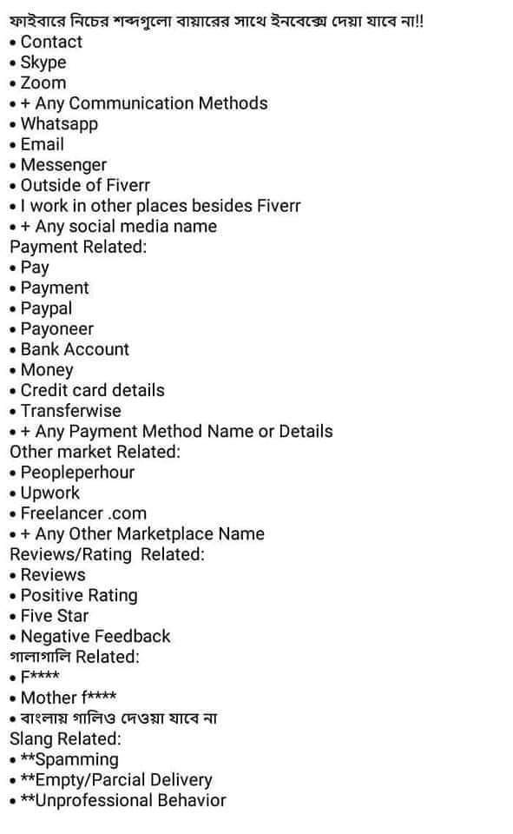

**Reply to Buyer Messages to Win a Job**

Will be discussed in a live class

**Cross-sell and Upsell Your Other Services to Scale Up Your Earnings**

Will be discussed in live class